Chapter 9, Problem 79.

- Calculate the phase shift of the circuit in Fig. 9.82.
- State whether the phase shift is leading or lagging (output with respect to input).
- Determine the magnitude of the output when the input is 120 V.

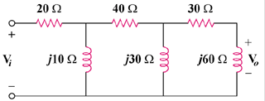

Figure 9.82
For Prob. 9.79.

